TEST OF ROAMING

VOICE
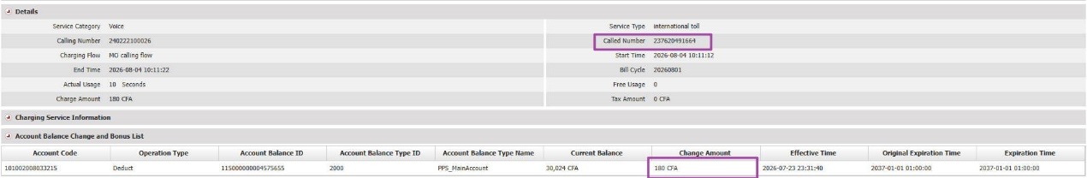
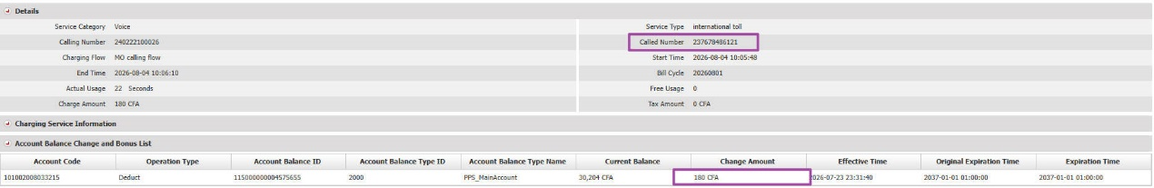

SMS
